Group number: 06

Names: Ahmed Sattar 19p-1672
Hifza Majeed 19p-1652
Wahaj Tahir 19p-1673
Atif Mehrban 18p-0024
Muhammad Hassan 17p-6157

Organization name:

Ran’aa Child Welfare Foundation
(A Ray of hope)

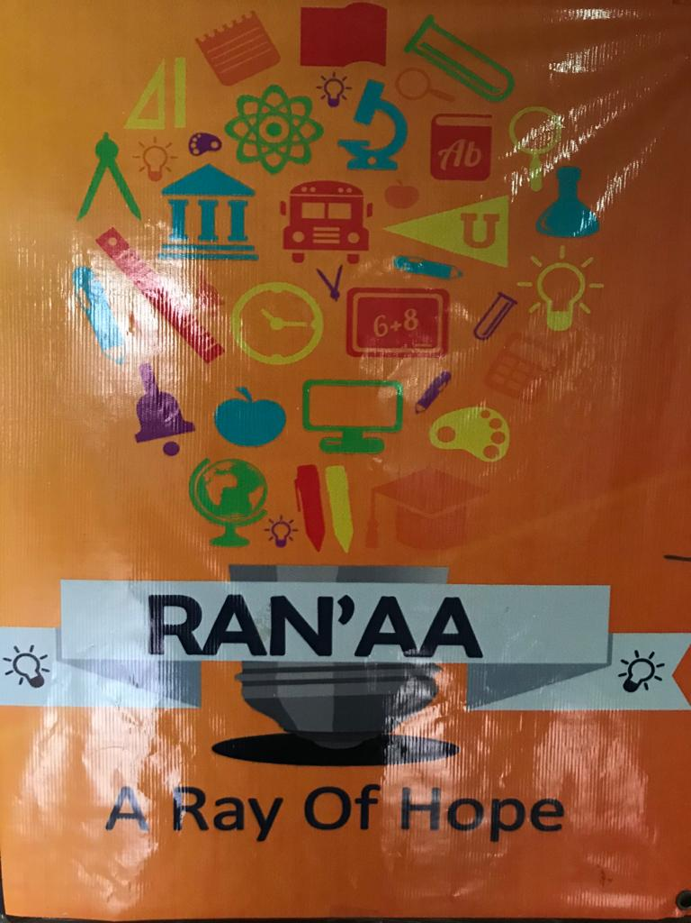
Foundation Run by:
Maam Mahvesh Ali Khan

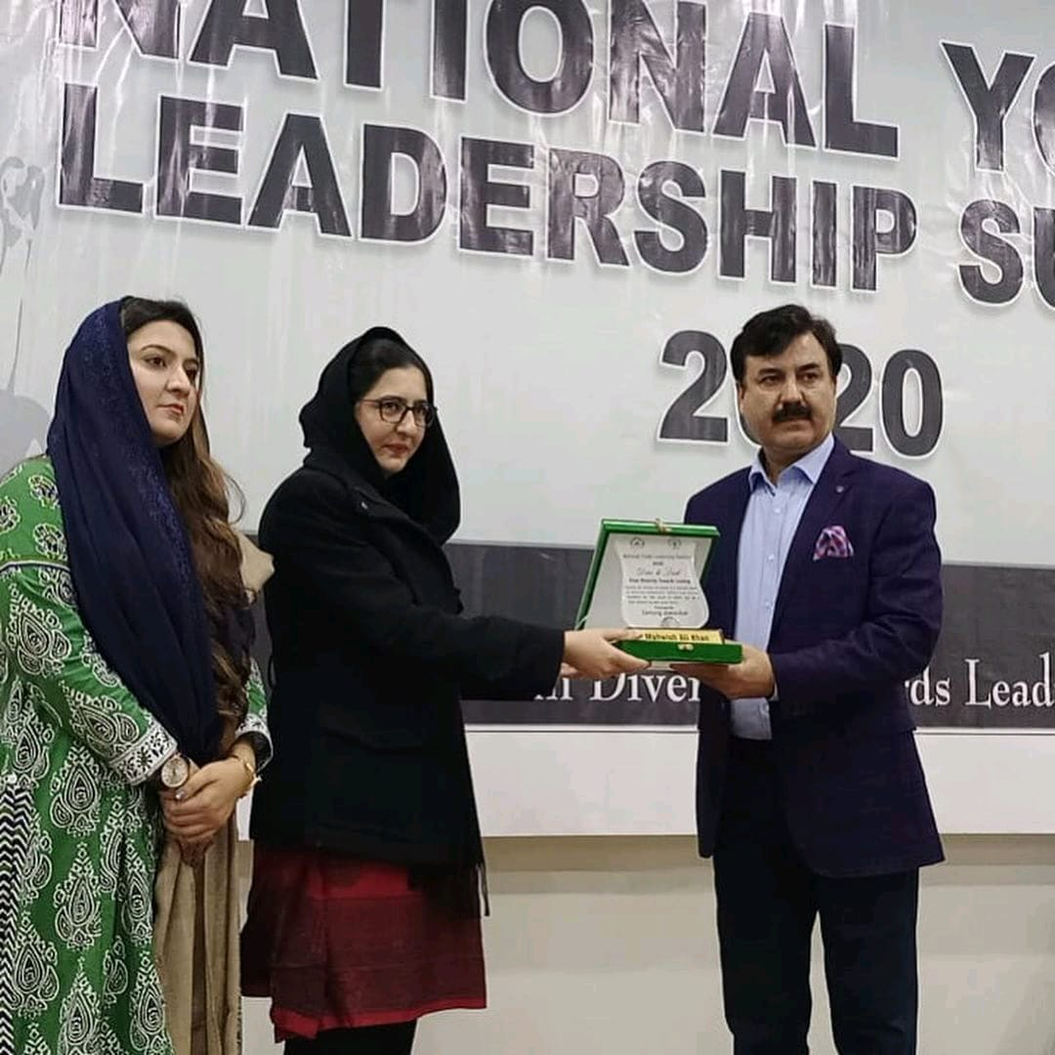

Historical Background:
So basically this organization was establish in 24 October 2016,This foundation was inspire by the incident of child who die due to cancer unfortunately that money which was going to be invest on his treatment it was invested in this foundation. This organization is running by Mrs Mahvesh. She is the CEO of this Foundation and doing great job for the humanity.

Impressum of Organization:
Ran’aa Child Welfare Foundation is a Peshawar based educational setup facilitating underprivileged and street Children of Peshawar providing them with necessities including school books, uniforms, food and pocket money. The children are taught mathematics, General Sciences, English and Art. Ran’aa Child Welfare Foundation is a charity organization and relies on donations to meet its day to day expenses.

Goal of this Foundation:
- Is to motivate the parents to educate their Childrens
- give them facility to the needy children to get themselves educated
- to provide them with basic needs like one time meal, a bit of money as reward.
- To groom the personality of the children .
- free quality education is offered to Street children and the less fortunate so that they can also have a bright future.

Type of children in foundation:

Abusive child
Orphan child
Labor child
Street Children
financially weak child

Manager roles:
Maam Mahvesh Ali Khan is the CEO of the organization, who makes this organization and running it from past 4 years. Her role is to manage all the circumstances of the organization and meets all the requirement of the organization.

Top Manager:
Maam Mahvesh is the first line manager in organization who discuss all the queries with CEO and direct approach to the CEO. Simam manage all the dealings of the organization and after that discuss it with CEO.

Second line Manager:
Faryal is the second line manager in organization working as HR in the organization.She deals with the new hiring employees and check out their CV,s and capability and check whether they are eligible for this post or not.

Functional Approach:

Planning:
The main plan of this foundation is to adopt labor children,Abusive children, orphan children and teach them manners, educate them and grooming their personality and force them to get education.

Our point of view to provide the physical support for children who are not supported by their families. The plan is well organized it seems.

Organizing:
There are multiple ways this foundation is organized and different structured of organizing the thing are applied in different ways.

For Example:
If a child come to foundation for admission and give excuse that he/she couldn’t afford, well in that case foundation will gonna visit child’s home and do proper inquiry about whether his/her parents could afford education expense or not.

Leading:
To accomplished the organizing goal The CEO and manager lead their employees how to accomplish or in which directions and ways they will complete the task.

Controlling:
The whole team under CEO and Top manager monitor the work that had been held in the organization.

Skill Approach:

Technical Skill:
It seems to us that they had well knowledge and capabilities to complete the task . They have been running this organization from past 4 years so they are well known by their work .

This foundation use so technical skill
Human skills:
They are working like family and do their best to solve the problem of the organization.Interaction is too good and our group is so impressed.

Conceptual skills:
They are working from past 4 years and they have a very good experience to approach and solve the problem.

Characteristic of organization:
Their motive is also to groom the personality of the children and provide them with basic need like one time meal,money as a reward and after that their children got admission in good schools and as they become come to the track of education.This organization is non-profit organization. This organization is for that children who cant afford school fee at all and specially for labor workers.

Organizational Culture and Environment in Ranaa’s Child welfare Foundation
Attention to detail:
In the welfare organization I saw employees are expected to be accurate in their work and high value on attention to detail to perform their tasks.In our point of view attention to detail doing more and to focus on her Goal.
Innovative Culture:
We talked with the management and other employees and we personally observed the environment looked innovative and risk taking they uses the digital media and all digital tools which are necessary for welfare organization, when we Visited all the management used latest technologies.
In our point of view in this foundation use more technologies and use best technology way to teach the children. In this foundation the multimedia result no good I suggest use best multimedia to teach the student.

Stability:
In the welfare organization there is stability what they were telling to us that is also implemented as a proper way, coordinate and align individual effort for greatest levels of efficiency.
I suggest to increase the stability level
Team Orientation:
People are team oriented each task is organized around whole team, the environment of organization is team oriented in a good way

Our point of view the team orientation level increase and also work together and discussion level has increase
People Orientation:
All the management decisions take into consideration to all the employees working in that culture it would not affect them.

Aggressiveness:
People in the organization are so cooperative and so good and tell us each and everything instead of word“Aggressiveness.” so easy going with us at first meeting.
Outcome Orientation:
In the welfare organization management focus on techniques and processes to achieve the outcomes
In my point of view welfare foundation needs just focus on results and outcomes.

1.1: Decision-Making: The Essence of the
Manager’s Job

Identification of a Problem:
In Ranna’s Foundation close due to COVID-19 so all thing close and teaching of student stopped so this problem here suddenly.

Identification of Decision criteria:
- Try to reopening the foundation
- Conducting online using google meeting app
Allocation:
Try to reopening chance is less
conducting online but face many
connectivity issue on student side.
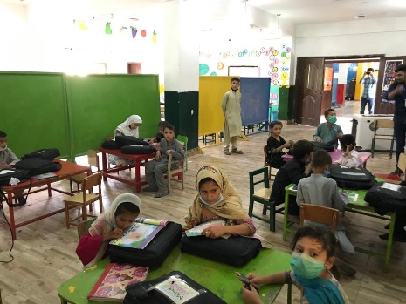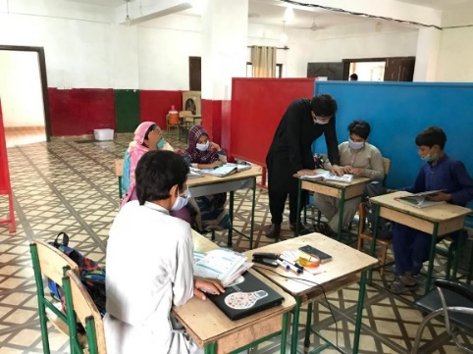

Analysis of Alternative:
Our team arrange a full open campus means to sit all the student have some distance and spread to each other.

Selection:
The ECO and 2nd line manager decided Selecting the online teaching method
So all the student follow this decision

In decision making play the important role of ECO Mahesh and 2nd line manager.

Rationale Decision making:
ECO and 2nd and 1st line manager decided how to solve the problem all the manager provide her on opinion But ECO decide the best thing selecting for her foundation and student in other cases the ECO play an important role in decision making but Managers make decisions rationally, but are limited (bounded) by their ability to process information.

Intuition:
CEO make decision based their past Experience and she batter know how to solve the problem and she also face this problem but in other way so she decided to conducting a classes online
The ECO decision based on all the emotion and feeling and also to view her feeling to decide any thing

In my point of view:
They choose the recording lecture and also online and feather provide in hard form and collect daily base report The ECO also collect the and check the report of all the teacher working well or not.
Because I see in foundation and school, they send the work but not know the student doing her work properly and not show her interest.

Structured Problem and Decision:
The problem is here and the manager know how to solve them, and also prepare for any kind of problem. In this foundation some people come for visiting the foundation so many works are pending and the manager known how these works be done and which method to use how we work.
In these foundations when he starting face many problems because they teach the street child so now in this time, they known how to solve the problem

Decision-making Styles:
Decision making style of the CEO is conceptual.
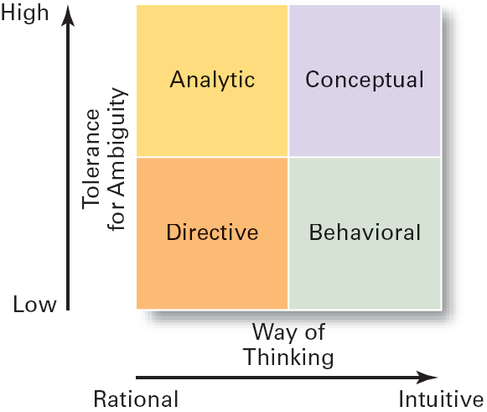

1.2: Planning:
- The goal of Rana,s foundation is to educate the children and also the labor child and help the needy and poor children.
- Their goal is to make parents aware of the education and make them able to educate their child instead of doing labor child.
- They take children from the roads and street and provide them with basic necessity of life like food and clothes and a little bit money as a reward.
- They hire teachers for the education and proper counselling of children and their parents as well as.

Purpose of planning:
- The purpose of Rana, s foundation is to guide the parents and educated labor child and poor children who can’t afford education.
- They guide their parents properly and accrue them that their child will educate and took admission in good school after getting his/her primary education from the foundation.
- They even don’t waste a little bit time of their children and also perform co-curricular activities so that a child groom. These all things are including in the planning of the foundation.

Elements of planning:
They provide a proper guideline to their students and see is that foundation completing the criteria of the performance.They accomplished their goal by providing their students a proper and good education, two times meal and money as a reward.People funded the organization and they make all their needs by the funds.They meet all their expense by funding.

Types of Goals:
There are two type of goals
Financial goals
Strategic goals
- It will see that are funding of the foundation meeting the both ends of the financial needs or not. Can our foundation afford more children or not or we may go with them? Is that funding affords the current the students or not. These are all with the financial goals of the foundation.
- This goal is related with the other foundation that are standing beside the ranaa foundation. What are the things that are providing in the other foundation but not in ranaa? It will give a competition in the external environment.

Types of plan:
Strategic plan:
It will see that organization is completing its goal or not and all the teachers are doing their task properly or what are things that can improve the entire foundation.

Operational plans:
The ranaa foundation found seriously needed and poor child and take them to their foundation and
Provide them with basic necessity of life and do proper counselling of their parents and after primary education they admit them in good schools.

Long/short term plans:
Ranna foundation is not long-term plan neither short term plan they educate their children and admit them in good schools. They admit their children in good schools when they are able to get admission so it is not a long- term plan nor short-term plan.

Specific plan:
The plans of this foundation are clear that to educate needy and poor children.

Directional plans:
The directional plan of ranaa foundation is to make children educated and provide them with right path and make future of that labor child bright.

Management by objectives:
In this foundation both manager and employee agree to do the task because the purpose of this foundation is to educate. If they make any decision so the CEO and manager will agree on it. After successful progress they are awarded with rewards by the CEO. They all are giving their best for improvement of the foundation.

Conclusion and my point of view:
In my point of view this foundation is giving their best to reduce labor child from the society and make parents aware of the importance if the education so that they will make their children educated. This is a good way to reduce labor child from the society and make a good and educated society.

1.3: Strategic Management:
Ranna’s Foundation have a good hand when it comes to management responsibility for a long-term Mission. There are few things to keep in mind.
- Current Mission
- Goals
- Defining strategies

Current Mission:
Ranna’s Foundation main Mission is to educate and take care of the children who are poor, abuse, orphans, needed etc. To educate them, to groom them and make them a better person and for the country.

Goals:
Now the goals are the sub parts of main mission that how will you going to do it or what will steps you will set in order to achieve main mission and I have observer that they are really good at setting goals like they know their work and how they are doing and how to make it done in best ways by setting goals.

Strategies:
Strategies are made by looking “what you have and what will be needed”, In order to achieve a goal. The foundation has a very good and experienced stuff they plan very symmetrical about everything that how to make things done in best scenarios and built a strategy for it. I have observer it that they have a team work, they built and perform strategies together and execute them.

SWOT ANALYSIS OF Ranna’s Foundation:

S  STRENGTHS | W  WEAKNESSES | O  OPPORTUNITIES | T  THREATS
- Foundation has good and Experience staff.  - Top Manager level to bottom level manager they know their work very well.  - Team Work capability  - Management Skills,communication skills,Time Management.  - Responsibility  - Laptops and projector Technology  - Digital learning  - Quality Education | - Small Area  - Limited amount of students can be admit  - Government affairs on property  - old furniture  - out-dated Technologies  - Care taking of child must be improve  - Resources like limited amount of books and Laptops. | - If a employee is Student Then foundation pay 1semester fee of that student.  - Internship gives a good reputation on the CV.  - A person will be awarded with valuable certificates. | - Government is against not this foundation but the land where it is located.  - Parents hesitate while sending their children to foundation.

Formulating Strategy:
Strategy formulation refers to the process of choosing the most appropriate course of action for the realization of organizational goals and objectives and thereby achieving the organizational vision. In Ranna’s Foundation I have observe this strategy would not have much Importance as it should be given.

Setting Organization Objective:
As I told in Current Mission. The objective of this foundation is to help the child for better future.

Evaluating the Organizational Environment:
It is a Not loss,Not gain institute. So I don't think so it really have a competition with other institute,The foundation should discover its own strengthen and weakness.

Setting Quantitative Targets:
Try to set up the real goal in order to achieve the goal state and try to remain in the lane and focus. I think the foundation is on the lane and it is achieving its goals.

Performance Analysis:
Checkout the strategies you made to achieve the goal whither they are working fine or not if it they don’t then change the strategy. Management of Ranna’s Foundation are well skilled and they know what they are doing and how to do that.

Choice of Strategy:
IF the strategy is working after the analysis than go for the course of this strategy it will help you achieve the goals otherwise find new one.

Implementing the strategy:
After the formulating strategy and after getting the best analysis,Implement the best strategy you get it will help you to achieving goals successfully.

Evaluate the Results:
After all this action you will recieve the result which you apply early and save them for later it will help you to have a look back what what strategies you have performed.

1.4: Planning tool and techniques
Environmental scanning is check and it is balanced according to the environment.
Competitor intelligence allows to compete with others and its help the foundation to move next following steps to work hard to maintain the level.

Global scanning admires to control the outsider views and shows performance according to the main points.
Forecasting gives the prediction what come next most step to continue this work of the foundation .

Techniques are used for this to how the Quantity of the students allow in this foundation and how much we can handle easily.
On the other side Quality students required for the output and how much we can generate quality students and transfer them to others schools.
Benchmarking leads the competition level among them to show output and competitors show more hardwork to manage against it and impacts on the foundation.


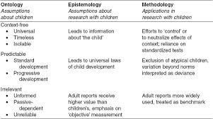

WE can generate more outputs in this way against these competitors leads good work in that foundation.
Techniques are used for allocating resources in this way we can control most of levels in the foundation.
Financial requirements are check and balanced by manager in foundation.
Physically they are adjust their requirements used according to that need.
Human resources are check i-e skills,knowledge etc when they achquire a new staff member.
Budgets are to be set according to the last year spending amount in that foundation.
All the expenses revenues generated to be noted for the next moments.
For the foundation it is not necessary the fixed budget its almost variable budget .
Schedules are to arranged yearly what have to done this year and what cost of all this foundation have last year it shows the total budget.
It shows the coordination of various things used in foundation.
Techniques are used for these scheduling.
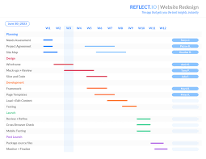

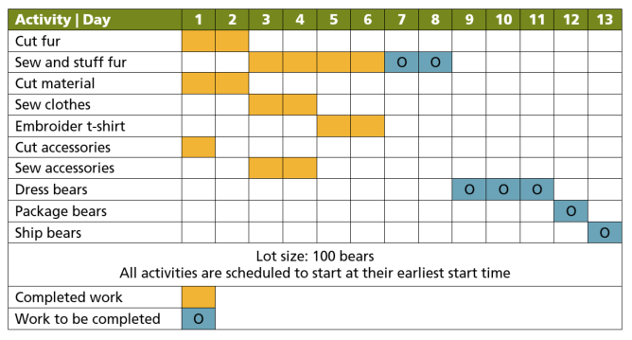

Gantt chart which shows how much cost per year spend on foundation and it shows the individual work of each person.
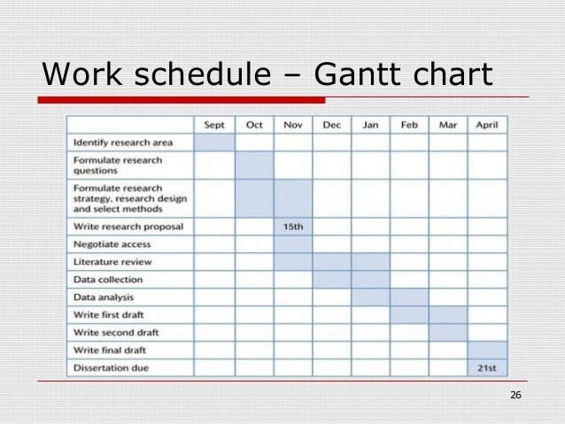
Load chart shows the individual task divided in horizental form to show some behavioural and each person have a record of each task.



Breakeven anylysis after some time total expenditure cost and revenue generated on that base.
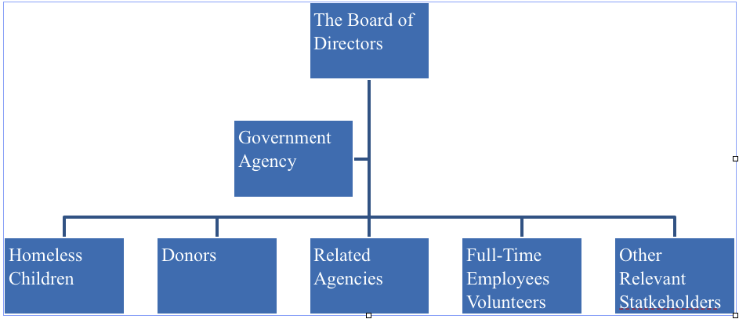
This foundation works on the variable price due to dependency of the students in the foundation.

1.5: Human Resource Management

In the Ranaa’s Foundation, we noticed a few points related to Human Resource Management people are self-organized responsible and accountable for all or most aspects of making them better. The Decision related to Recruitment, Recruitment Selection, etc are Centralized and the most important the proper setup of Human Resource Management (HRM). Employees in Foundation who performing their tasks effectively and efficiently. HRM used the Internet and E-Learning for Recruitment and Training Using Website, and Selection of Employees are based on their merit and skills Using Written Exams, Interviews, and some other methods according to Job Description.HRM of Ranaa’s Foundation forecast the supply of employees and demand.
Organizational structure:
In ranaa foundation everyone is assigned different tasks according to their specialization and experience and their organizational structure is very efficient in his work and also doing their best in work.

Work specialization:
Mam kashmira in the foundation takes the interview to every new candidate that do job in the foundation. The foundation always hire a staff after seeing their work experience.

Departmentalization:
They don’t have different department, actually it’s a foundation where different child study and at the other side of the foundation they have higher class students and beside it there an office of the manager.

Chain of command:
Chain of command is on the CEO hand who instruct and handle all the dealing of the foundation and after that manager implement that.

Span of control:
Actually it’s not a very big foundation and CEO takes and handle all the dealing in the foundation and if something happens in the foundation so CEO is the responsible and after that manager who maybe didn’t implement all properly.

Centralization and decentralization:
Mam Mahesh takes all the decision and as she takes decision so she is responsible and she is the backbone of the foundation and manager offer didn’t take decision without the permission of the mam Mahvesh.
She always motivate his staff and after that her staff did best in the work.

Mechanistic and organic organization:
It is organic organization who do not have high degree of jobs actually it is small organization and which at least 100 students are studying and they have open network because they take child from street and educate them and after giving primary education admit them in the good schools .

Team structures:
The entire foundation are assigned different task, teachers in the foundation study children and manager lead overall foundation and empowered their employee.

Matrix and project structures:
It’s a foundation who take children from road so specialization is not imperative because primary education is now given by every educated students or person, and when work is load is more than CEO assigned different task to manager and teachers and at their free time they all did that.

Project structure:
Manager the CEO and all the teachers and staff handle all the project beside all the foundation works
Virtual organization:
It’s a small organization and when need arise the staff work extra hours to meet the workload of the organization and they do not hire staff temporarily.

Network organization:
It’s a small organization but its outcome is major business because when that children took admission in the schools and study on scholarship so it the proud moments of the foundation.

Modular organization:
It is not a modular organization actually its outcome is the proud moments of the organization when that children got admitted in schools on scholarship after getting primary education.

Motivation:
The whole staff of the foundation is the energized and wiling to his/her task according to their specified field. The teachers give the students friendly environment in which they can groom themselves more.

Motivation and needs:
- Three needs theory:
- Need for achievement:
They take child from road and educate them this is the need of achievement of this foundation.
- Need of power:
The public and other people are not fully involved in it but some gives fund to the foundation so they meet their both ends. The government should help and fund that type of the foundation and also influence them to do that type of social work in the society.
- Need of affiliation:
The teachers in the foundation are also advancing their skills and also make students able to do best in the future.

Benefits of participation in goal setting:
- It increase the ratio of the success of the foundation.
- It increase awareness in public and specially labor child’s parents to make their child study
- It will low the child labor in the society and as result a successful society will raise.

Reinforcement theory:
It is a positive reinforcement because when that child will grow after getting education then he will live his life as successful person and that little step make him a good person as well as.

Job design:
The CEO of the foundation assign task to all the staff of foundation because it is not so large foundation.
The overall handle is taken by the CEO of the foundation.

JOB Enlargement:
It is not a big and large foundation in which 100 of workers will work it is a small foundation in which almost 50 to 80 student study and a manager and teachers.

JOB enrichment:
The responsibility of the staff is very imperative because is the matter of the future of the children and the staff take his work very seriously do with all their heart and energy.

JOB characteristic:
Skill variety:
The teachers that are giving him education are graduated from a reputable university and its enough for the students at primary level.

Task identity:
Everyone is assigned a task in which his/her is better and do much better and grooming his/her after time to time.

Task significance:
The job of the all the member of the foundation is also crucial because is the matter of the children

Autonomy:
The staff his independent but no much because his/her id answerable to CEO of the foundation.

Feedback:
The workers are doing their best and at the hour of need give the extra time to the foundation.

Expectancy theory:
- :Effort:
There is no training session of the foundation and the teachers in which they can get better.

2: performance:
The performance of the overall foundation and the staff members are very good and willing to do the task.
3: rewards:
The children of the foundation are rewarded with money and as well as staff member of foundation will also award money on the better performance.

Leadership:
Seven Traits Associated with Leadership which helps in leadership. In this foundation leadership is the important role to lead this foundation. I.e Drive,Desire to lead,Honesty and integrity,Self-confidence, intelligence,Job-relevant,knowledge,Extraversion.

Behavioral Theories of Leadership:
Raan’a Foundation Democratic style: involving each and everyone,delegating authority encouraging participation.

Autocratic Style:
Dictation work styles,centralizing decision making and limiting work burden.
●Giving group freedom to complete work.
Conclusion : it is not effective way for this.

Consideration:
●Being considerate on followers ideas and
feelings. initiating structure: structuring
work,and work loads to complete on time.

●Conclusion: it only depends on the leader abi;ity
how that deals with their workers.
Decision making style of the CEO is conceptual

Concern of people:

●It more depends on the corning people that
attached to this.

●Output production: it depends on the working
load of employee.

●Conclusion: leaders do their good job for the
best output.

Managerial Grid:

●It how the leader manage the whole overload.

●Appriases 2 dimensions for managerial grid I.e
concern and production.

●Places managerial styles : impoverish ,team and
task management ,
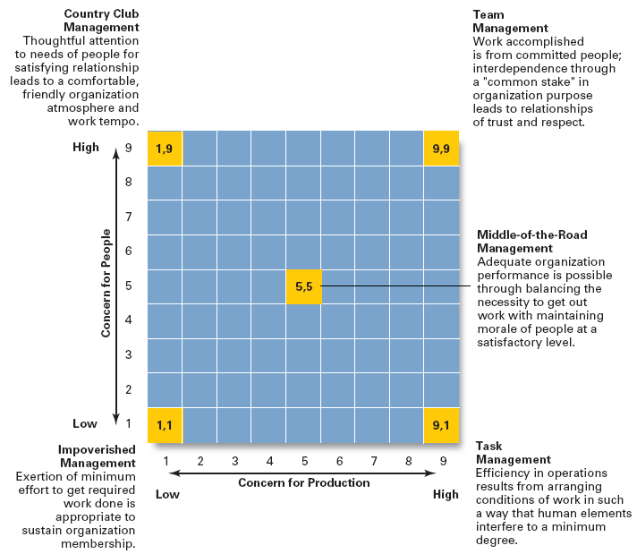
Contemporary views:

●Transactional leadership motivate the followers.

●Transformational leadership inspire followers totranscend their own self-interests.

Ethical leadership:

●This foundation promote ethical behavior by
exhibiting their personal traits of honesty and
integrity.

●Cross-cultural leadership: some universal
effective points of leadership I.e vision ,
protectiveness,encouragement,positiveness etc.
Gender differences:

●Males and females have different views for
different leadership holds.

●Men tend to use trasactional leadership.

●Women tend to use transformational leadership.

In the Ranaa Welfare Foundation, the best thing is the communication all the network around the foundation is well.
- The way of communicating is good using formal and clear messages. All the employees in the foundation use the latest methodologies related to interpersonal communication like Group meetings, Teleconferences, and Formal presentations.
- In Ranaa Foundation communication is verbal using images and body language.
- The workers and employees all are an active listeners.
- And the final point related to communication is communication flaws in Ranaa Welfare Foundation
  - peer-to-peer communication
  - Information moving from high-level employees to low-level

- The Foundation is politically correct



GALLERY:

